CHILDERLEY CONCERT IN ASSOCIATION WITH THE CAMBRIDGE SUMMER MUSIC FESTIVAL 2026

Eleanor and Gus
Guitar, Bass and Voice Duo
Thursday 23 July, 7.30pm. Gardens open from 6pm.
Long Barn, Childerley Hall Dry Drayton, CB23 8BA
(in conjunction with Childerley Hall)

A magical evening of music and intimate story-telling from a multi-talented duo passionate about showcasing music in its broadest sense.

Eleanor Grant and Gus McQuade have been captivating audiences with their unique combination of voice, guitar and double bass since their stunning debut recital at London’s Wigmore Hall in 2023.

They formed their duo as second year undergraduates at the Royal Academy of Music after became aware of their mutual passion for exploring multiple genres, from the Renaissance to the present day, embracing folk and jazz influences.

The duo won the Musicians’ Company’s prestigious New Elizabethan Award 2022/23, leading to their debut at the Wigmore Hall. Since then, they have performed at venues and festivals across the country. From Dowland to Dankworth, Britten to Joni Mitchell, Jacob Collier, Florence B. Price and Hildegard von Bingen, Eleanor and Gus will draw you into their musical world with a sublime combination of words, melodies, rhythms and harmonies.

Tickets: £32 (premium seating), £25 plus booking fee

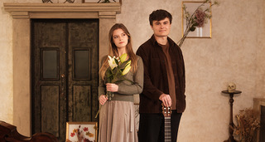 | 