Childerley - Shakespeare in the Garden
Sunday 26 July

A Garden Picnic Performance of Shakespeare’s The Merry Wives of Windsor
Curtain up: 3 pm performed by Durham University’s Castle Theatre Company
A riotous afternoon is guaranteed for the whole family!
Tickets: £18. Under 16s - £10. Under 10s – Free.
Available from the Childerley Website shortly.

Castle Theatre Company is delighted to announce its 2026 touring production of one of Shakespeare’s most entertaining comedies: The Merry Wives of Windsor. Packed with trickery, duels, and a whole array of unique costuming, The Merry Wives of Windsor promises a side-splitting night of laughter and chicanery.

New in town and down on his luck, Sir John Falstaff arrives in Windsor and attempts to woo Mistress Ford and Mistress Page, the wives of two wealthy residents. Meanwhile, the Pages’ daughter, Anne, is pursued by three suitors. With Mistress Quickly being paid by all three to put in a good word for them, chaos ensues as they all vie for her hand. In between duplicitous love letters, eavesdropping, and plain old trickery, events culminate in a fantastical nighttime confrontation in Windsor Park, where Falstaff soon realises that he’s got more than he bargained for.

Castle Theatre Company is one of the oldest performing arts groups at Durham University, and for over four decades has taken an annual summer Shakespeare tour around primarily the south of England and the USA, performing classic comedies on the lawns of stately homes, gardens, and abbeys.

The company is renowned for its high standard of performance, offering a full-length Shakespeare comedy that is suitable for all the family. 2025’s touring production of Twelfth Night was performed to sold-out audiences across England.

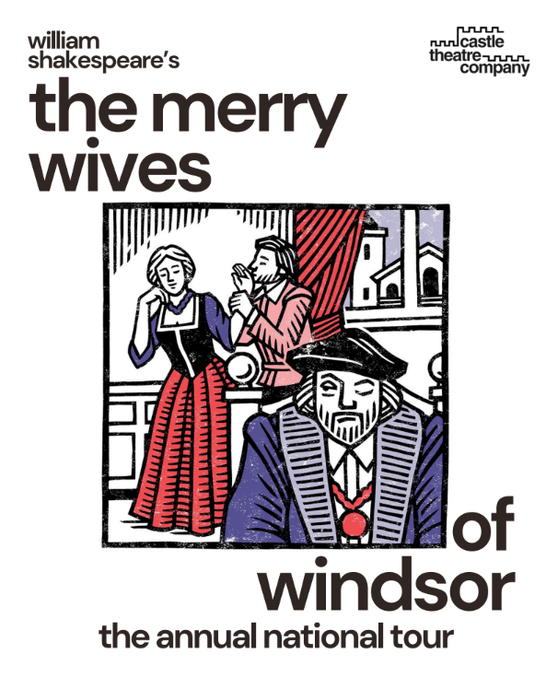 | 

